|  |  |
| --- | --- |
|  |  |
| PROJECT DOCUMENTATION CMPG 315-GROUP 8 |  |
|  |  |
|  | Group Members:   1. Nakooda, Tasmiyah (37226509) 2. DeGouveia, Marco(40899624) 3. Liphoko, Mohau(42524547) 4. Mabula, Palesa(37124315) 5. Mathebula, Michael(38925958) 6. Makhubela,Boiphelo(41368452) 7. Mogotlane, Nick(43230350) 8. Moremi, Olebogeng(40123316) 9. Patel, Riya(41914228)   10.Sparks, Jameela(41354850) |
|  |  |

Contents

PROJECT DOCUMENTATION CMPG 315-GROUP 8 1

Reflections 3

Packet Tracer Network Topology using Diagrams. 14

Description on the Topology, details on how devices are used, Configurations and how the overall network is structured and Justification on design choices and explanation on how the network meets the requirements. 15

Budget 23

Group Ethics Reflection on the Packet Tracer 24

Challenges faced: 24

Bring your own device considerations: 24

Part of the network most likely to need maintenance: 25

Parts to remain if company went virtual: 25

Group approach to managing project load: 25

Advantages: 25

Disadvantages: 26

Scheduling problems, not everyone may have been able to attend due to constraints such as petrol for small group discussions. 26

Technical difficulties such as network problems, easily distracted if there are outside factors that catch your attention whilst video conferencing. 26

Group Ethics Reflection on the Messaging App 26

Group Ethics Reflection on the Overall Project 29

Issues encountered on the Project. 30

Continuous Reporting part 1- Attendance list, 31

meeting notes and members tasks and responsibilities. 31

Screenshots on GitHub use 45

### Reflections

Nakooda, Tasmiyah (37226509)

The courses gave me insightful knowledge and helped me develop several critical soft skills that are essential to the success of our group project.   
I learned from the time management course how important it is to have a daily schedule and an organized morning routine in order to enhance productivity. I discovered methods to reduce distractions throughout the day, such as the SAVERS method (Silence, Affirmations, Visualization, Exercise, Reading, and Scribing). Efficient time management and prioritizing high-impact assignments will enable me to make a valuable contribution to the group's work.

My knowledge of collaborative coding and version control has grown as a result of the GitHub courses. I now understand the Git process better, including how to create repositories, branch, merge, and use commit messages efficiently. With these abilities, I'll be able to collaborate with my group members more effectively and keeping track of changes.

The training on project management highlighted the fundamental concepts of effective project management, including setting goals, making a timeline, and keeping track of developments. Planning tools like PERT charts and critical path analysis are now more known to me. Our crew will be able to maintain organization, fulfill deadlines, and produce an excellent final result by putting these ideas into practice.

Lastly, I gained practical network simulation experience from the Cisco Packet Tracer training. With this, I will be able to simulate the physical structure needed for the company's new office and solve any issues that may occur directly related to the topological network design process.   
  
Overall, these classes have improved my technical, planning, teamwork, and time management skills—all of which are essential for successfully finishing this group project.

DeGouveia, Marco(40899624)

After going through various short courses on time management, GitHub, project management, and Cisco packet tracer I have found the importance of learning skills to help develop myself and become more efficient in life. When going through the time management and project management courses I discovered the importance of going and setting goals and keeping track of what you must do every day. One big thing to note as well was the importance of tracking deadlines and tasks to keep track of your time and projects when working in groups.

When going through the GitHub courses becoming more equipped when using GitHub will help me in the future for any projects. Navigating the different features on GitHub has shown how this platform enhances collaboration among project members when creating different projects and how easy it is to collaborate with people from anywhere in the world. While completing these courses I have seen how important the value of teamwork is as a skill which is much needed when working in groups in order to be more efficient when working with deadlines.

For the last course Cisco packet tracer skills I learned how to navigate through the Cisco packet tracer application for phase 2 of the project when developing the network system for our project. All these skills have shaped my mind moving forward in life when managing my time and when working on tasks.

Liphoko, Mohau(42524547)

Embarking on my journey through Udemy's free courses exposed me to a wide array of subjects, from time management to Git, GitHub, project management, and Cisco Packet Tracer. Engaging modules and interactive exercises allowed me to delve deeply into each topic, gaining practical insights and knowledge along the way.

As I advanced through the courses, I began to understand the symbiotic relationship between effective time management and technological proficiency. Implementing strategies such as a morning exercise routine and prioritizing critical tasks while taking rejuvenating breaks not only improved my time management skills but also strengthened my self-discipline and resilience. Moreover, navigating through Git and GitHub enhanced my teamwork and communication skills, essential for collaborative work in professional settings.

Completing the project management and Cisco Packet Tracer courses further developed my organizational, problem-solving, and technical proficiency within a structured time frame. These skills facilitate smooth project execution, troubleshooting technical issues, and optimizing network configurations, enhancing my overall professional competence.

Looking ahead, I aim to refine my time management skills and deepen my understanding of Git, GitHub, and project management methodologies through continuous practice and exploration. I also plan to utilize my newfound knowledge of Cisco Packet Tracer to pursue opportunities in network design and implementation, while continuing to nurture my soft skills for personal and professional growth.

In conclusion, Udemy's free courses have equipped me with essential technical expertise and invaluable soft skills, positioning me to thrive in today's dynamic digital landscape. Through diligent application of the DIEP model, I am confident in my ability to excel in both personal and professional endeavors.

Mabula, Palesa(37124315)

**Time Management Course**

Time needs to be managed well to enhance productivity. I have learned the importance of having an everyday routine as that would help with tackling assigned tasks or having daily goals. The steps to having that include having a morning routine that consists of planning for the day ahead. I have learned skills such as how to set up my work time which includes steps on how to concentrate better and avoid distractions. The importance of the 80/20 rule which emphasizes the importance on focusing on my personal tasks that’s leads to me closer to achieving my goals than focusing more on other people’s tasks (which I can only use 20% of my time for that). Furthermore, I have learned how to create a time management framework using Excel in which I dedicate an hours or minutes in each task depending on the importance of the tasks and my goals.

**GITHUB COURSE**

I have learned the purpose of the platform GitHub, in which I have successfully installed into my computer using the tutorial and I have managed to navigate through it by watching the tutorials on how to setup an account and doing tasks such as: creating a repository, cloning a repository, how to create a file in the repository etc. I have also learned how to collaborate with other group members using GitHub and I further understood how to track, update and manage versions of project, this will lead a to an organized project plan.

**Project Management**

I have learned how to successfully manage a project using the short course that explained thoroughly using steps and examples on how to successfully create and finish a project in time with no problems. I have learned techniques on how to prioritize and break down project tasks into smaller steps as well as assigning a time limit into each task. Furthermore, focusing more on the time sensitive tasks. The other highlighted point is importance of communication with group members and how to effectively assign tasks that would lead to a positive environment.

**Cisco Packet tracer**

I have learned about the network simulation tool, learning how to design the network infrastructure as that would be of great benefit with the project we have been assigned with.

Mathebula, Michael(38925958)

**Time Management**

Prior to starting the course, my perspective on education changed, the traditional system emphasizes memorization whilst the course highlights real skills are learnt practically. The idea of a ‘morning ritual’ resonated with me, challenging the ‘one size fits all’ approach and inspired me to create a personalized routine that energizes and prepares me for the day.

Another interesting point made is ‘locking in’, this is a state where all distractions are eliminated and you only focus on your most important objective at the time, from experience this allows you to be more productive and efficient.

**Git and GitHub**

It was revision as I have used git before however I never fully grasped it, the course was very informative and easy to follow and it highlights the incredible prowess of git and github especially in terms of collaborating on projects.

**Project and project management**

The project management course wasn’t smooth sailing. The technical difficulties- unclear audio and abrupt video endings hindered my ability to engage. Despite this, the concepts covered resonated. Understanding project requirements and timeline was emphasized through the use of tools like pert charts.

**Packet Tracer**

A very interesting software with a transformative experience, its learning approach emphasizes practice and offered a dynamic playground, I had to build a home network, visualize how routers interacted with other IoT devices in a simulated environment and this ignited a desire to explore more in the world of network design beyond the virtual realm.

Makhubela,Boiphelo(41368452)

Reflecting on my educational journey I have learned the value of time management from the classes. Discovered that productivity can increase by organizing and upholding a good routine. This insight has changed my life and enabled me to get past my time management obstacles. My perspectives have been expanded and my ability to think critically and creatively has been enhanced by reading material outside of the curriculum. The technological skills I’ve picked up, have given me new opportunities and improved my technical competence and self-assurance. The significance of communication and planning in enhancing project efficiency has been emphasized in the project management course. Through my education in project management, I have gained a deeper grasp of risk, uncertainty, and essential project planning duties. Examples of these approaches are the Critical Path Method (CPM) and three-point estimate. I’ve learned a lot by using Cisco Packet Tracer firsthand. I now know how to visualize networks, configure devices, and simulate different networks. My networking skills have been reinforced by this hands-on experience. I’m inspired to keep utilizing Cisco Packet Tracer’s proficient capabilities and to use the information I acquire in my next networking endeavors. Additionally, I want to use the soft skills I’ve acquired—like time management and critical thinking in particular—in both my personal and professional life. I’ve learned so much from this experience, and it has given me useful information and skills. I’m excited about the possibilities these new abilities will present to me.

Mogotlane, Nick(43230350)

Taking Udemy courses on Time Management, GitHub, Git, and Project Management has been revolutionary, providing me with a varied set of soft skills necessary for professional success. In learning Time Management, I realized the importance of investing my time properly, avoiding routine mistakes, and establishing rituals that maximize productivity. Understanding the inconvenient state of flow has become critical to my efficiency, as has understanding acts that move me toward my goals, while acknowledging the slow process of true progress.

When I first started using Git, I learned fundamental concepts, finished my installation and setup skills, and developed an efficient Git workflow. This core knowledge improved my knowledge of version control and the use of Git in collaborative development environments.

Furthermore, GitHub training helped me understand its role as a collaborative platform, allowing me to create repositories, successfully manage branches, and use Git commands to improve communication and code management processes.

In Project Management, I acquired a knowledge of project structures, process groups, and knowledge areas. PERT and CPM techniques have helped me understand project scheduling and critical path analysis, while introduction to monitoring tools like Microsoft Project 2013 and Primavera has improved my project management capabilities.

Overall, these courses improved not only my technical knowledge but also my soft skills, helping me with better productivity, teamwork, and project success.

Moremi, Olebogeng(40123316)

Reflecting on my recent learning journey, I am struck by the profound impact it has had on my personal and professional development. The courses I have taken on Udemy and Cisco Packet Tracer have not only expanded my technical knowledge but also enriched my soft skills, shaping me into a well-rounded individual.

The Time Management course was a revelation. It taught me the art of prioritizing tasks and working efficiently. I learned that time is a resource that, when managed well, can lead to increased productivity and reduced stress. This skill has been invaluable in managing my project work and meeting deadlines.

The Git and GitHub courses introduced me to the world of version control, a crucial aspect of software development. More importantly, they highlighted the importance of collaboration and effective communication in a team setting. I learned that successful projects are built on the foundation of strong teamwork and clear communication.

The Project and Project Management course was a masterclass in leadership. It taught me how to plan, execute, and lead a project from inception to completion. I learned what is crucial to manage resources, mitigate risks, and lead a team towards a common goal.

Lastly, the Cisco Packet Tracer course enhanced my problem-solving skills. Designing and troubleshooting complex network systems exercises was a challenging yet rewarding experience. It taught me to approach problems with a critical and analytical mindset.

In conclusion, these courses have equipped me with a diverse set of skills that are not only relevant in the field of computer networks but also transferable to other areas. I am excited to apply these skills in my future endeavors and continue my lifelong learning journey.

Patel, Riya(41914228)

The path through the many courses provides special knowledge and abilities. I can say that the courses have taught me a lot, which has improved my competence and confidence all around.

Starting with the first course's study of Time Management, I developed a deep comprehension of self-control, goal-setting, and personal growth. Learning to prioritize tasks has made it efficient for in getting things done, as well as setting goals which has helped me stay focussed and kept me motivated.

Moving onto the Git Expert course, I improved my flexibility and communication abilities, which are essential for productive teamwork in a variety of professional settings. I have gained the problem-solving abilities necessary for any technical function. I'm still getting used to all the details of the platform. It's been tough figuring out some tricky issues, but I'm slowly getting better and enjoying the chance to learn new things.

Moving onto the Project Management course, this course expanded my skill set. I have gained an understanding about handling project limits, sorting tasks, project tools and methods. This also gives me practical ways to manage projects effectively.

Lastly talking about the Cisco Packet Tracer, mimics different network setups, understanding network setups, commands, device setup, functionality. But because it's a new tool for me, there has been a learning curve, and I'm still getting used to knowing how to use its capabilities properly.

In conclusion the courses improved my skills and confidence, though adjusting to new tools was challenging.

Sparks, Jameela(41354850)

**Time Management**

The time management video emphasizes the importance of having a morning routine, setting work time to eliminate distractions, and having an evenly proportional break, which I lack. It advises setting ten goals for daily work, planning for weekly and daily tasks, and using an 80/20 rule to focus on personal goals and earning money. An excel sheet can help track progress towards these goals, ensuring that 80% of time is spent on personal goals and 20% on others' problems and desires. This approach can help improve productivity and overall life satisfaction.

**Git Started with GitHub**

Learning Git basics and GitHub for team projects is crucial, requiring familiarity with the command line on Windows and Mac. Staying open to learning is key for smooth collaboration.

**Project and Project Management**

This video provides an in-depth understanding of project management, including its definition, processes, and tools. I learnt initiating, planning, execution, monitoring, controlling, and closing, each involving procedures for delegating and managing the project. The video also discusses methods like PERT Chart, Critical Path Methods, and three-point estimation, which thankfully I am familiar with.

**Packet Tracers**

This course uses Cisco Packet Tracer to simulate various network types, enhances networking knowledge, and covers CLI commands, device configuration, desktop tab, and services tab. Users must download and install software, which I did and now the only battle is to get it to work.

Problem Overview Packet Tracer

* Infrastructure scalability – The network system should be able to accommodate expanding business requirements.
* Security concerns – Ensuring data breaches such as malware attacks don’t occur and ensuring strong authentication processes so that unwanted devices can’t access the network by ensuring strong passwords and authentication.
* Network performance – bandwidth limitations, making sure all devices connected to the network are given the right network speeds in packet tracer guidelines.
* Remote work challenges – Ensuring VPN servers can handle traffic from remote workers and remote workers can access the network from home.
* Device management – We must allocate how many devices each staff member will have in each of the designated rooms and which devices will use wired network access points as well as the Wi-Fi.
* Device coverage – We must ensure full coverage and capacity for all devices both wired and wireless throughout the building.
* Meeting rooms – This room requires a special setup for teleconferencing with a higher capacity for Wi-Fi because of the increased number of people this room can hold.
* Open floor space – The open floor space must be able to accommodate many staff with extensive wired and wireless connectivity.
* Machine room - This room requires as per company policy that all routers and major switches be located in this, and we may only use switches with less than 8 ports outside of this room and switches with more than 8 ports inside the machine room. There also are pre-existing servers capable of storage and network service for remote work. Lastly, we must ensure that all traffic moves from the machine but not necessarily from the servers.
* Technician office – Must ensure it has more wired access to the machine room and has increased wired access points for potential extra equipment.

### Packet Tracer Network Topology using Diagrams.

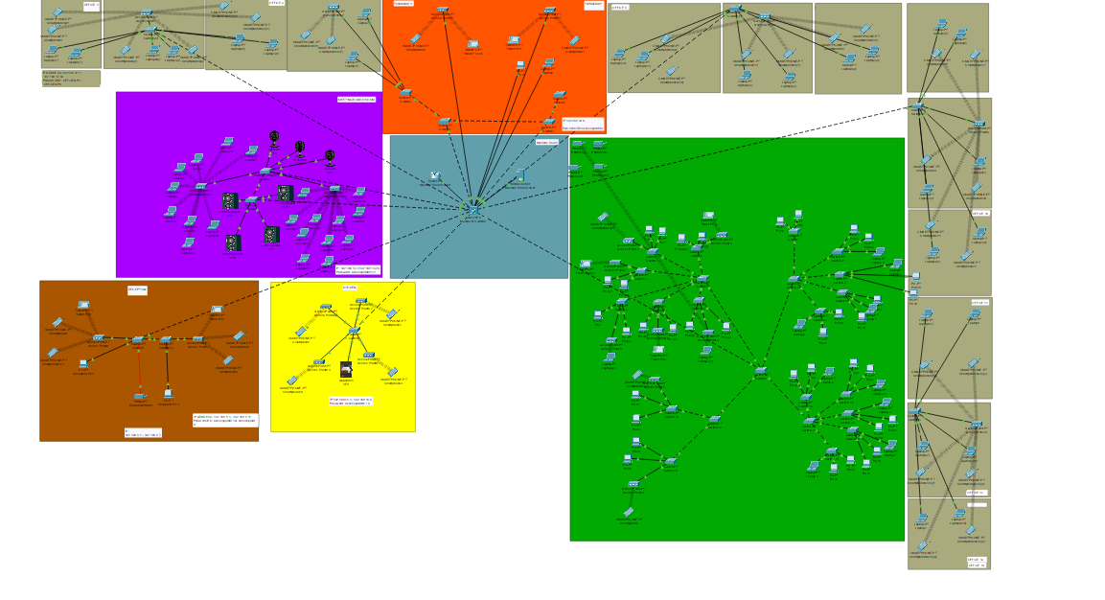

### Description on the Topology, details on how devices are used, Configurations and how the overall network is structured and Justification on design choices and explanation on how the network meets the requirements.

**Offices:**  
The network topology used for the offices section is a star topology. Each office is connected to a central switch (Switch16) through access points. This approach has several advantages:

1. Centralized management: By having a central switch connecting all offices, network management and configuration becomes easier and more efficient. Any changes or updates can be made at the central switch, reducing the need for individual configurations in each office.
2. Fault isolation: In a star topology, if there is a failure in one of the connections or devices in an office, it does not affect the rest of the network. The failure is isolated to that specific office, allowing the other offices to remain operational.
3. Scalability: Adding or removing offices becomes relatively straightforward in a star topology. New offices can be easily connected to the central switch without disrupting the existing network.
4. Security: By isolating each office's network segment, it becomes easier to implement security policies and access controls. Unauthorized access or network threats can be contained within the affected office, preventing it from spreading to the entire network.

Using static IP addressing instead of DHCP (Dynamic Host Configuration Protocol) for the office devices has the following advantages:

1. Consistent and predictable addressing: Static IP addresses ensure that devices have a consistent and known IP address, making it easier to manage and troubleshoot network issues. With DHCP, IP addresses can change over time, potentially causing confusion and connectivity problems.
2. Improved security: Static IP addressing reduces the risk of unauthorized devices joining the network and obtaining IP addresses, as each device must be manually configured with an approved IP address.
3. Reliability: Static IP addresses are not subject to potential DHCP server failures or conflicts, providing a more reliable and consistent network configuration.
4. Specific applications: Some applications or network services may require devices to have static IP addresses for proper functioning, such as web servers, FTP servers, or network printers.
5. Network segmentation: Static IP addressing allows for better control and segmentation of the network, as each office can be assigned a specific IP address range, ensuring isolation and preventing address conflicts.

While DHCP can be more convenient for dynamic environments with many devices joining and leaving the network, static IP addressing provides better control, security, and predictability, which is often preferred in a corporate or office environment where device configurations tend to be more stable.

**Reception:**  
For the reception area, a similar star topology approach was used, with a central switch (Switch2) connecting all the devices in the reception through access points.

This topology offers the following advantages for the reception area:

1. Centralized connectivity: All devices in the reception area, including the desktop computers and wireless devices (smartphones), are connected to the central switch. This allows for easy management and monitoring of the network traffic in the reception area from a single point.

2. Scalability: If the need arises to add more devices or workstations in the reception area, it can be easily accommodated by connecting them to the central switch through additional access points or wired connections.

3. Isolation: The reception area network is isolated from the other sections of the building, such as offices or the machine room. This separation enhances security by preventing unauthorized access from other parts of the network.

4. Printer connectivity: The networked printer in the reception area is directly connected to the central switch, allowing all devices in the reception area to access and share the printer resources.

5. Guest Wi-Fi segregation: The diagram indicates that there is limited Wi-Fi access for guests. By using a separate VLAN or dedicated access point connected to the central switch, guest devices can be isolated from the internal network, ensuring security and preventing unauthorized access to company resources.

Regarding the use of static IP addressing instead of DHCP for the reception area devices, the same advantages mentioned earlier still apply:

1. Consistent and predictable addressing for easy management and troubleshooting.

2. Improved security by reducing the risk of unauthorized devices joining the network.

3. Reliability and independence from potential DHCP server failures or conflicts.

4. Specific applications or network services that may require static IP addresses for proper functioning.

5. Better control and segmentation of the network by assigning specific IP address ranges to the reception area.

The star topology combined with static IP addressing provides a structured and secure network setup for the reception area, allowing for centralized management, scalability, isolation, and easy integration of shared resources like printers.

**Technicians Office:**  
For the technicians' offices, a hierarchical network topology has been implemented using multiple interconnected switches and access points. This approach offers several advantages:

1. Separation of concerns: The technicians' offices are divided into two distinct network segments - one for regular office work (Switch24 and Access Point75) and another for office equipment maintenance (Switch25 and four access points). This separation allows for better security and traffic management between the two different use cases.

2. Scalability and flexibility: The hierarchical design with multiple switches and access points provides scalability by allowing for easy expansion or reconfiguration. Additional devices or access points can be added to the respective switches without disrupting the entire network.

3. Redundancy and fault tolerance: By having multiple interconnected switches, the network topology provides redundancy and fault tolerance. If one switch or connection fails, devices can still communicate through alternative paths, minimizing downtime and ensuring network resilience.

4. Direct connectivity to the machine room: The technicians' offices have a dedicated switch (Switch23) that provides direct wired connectivity to the machine room. This allows for efficient and secure communication between the technicians' devices and the servers or network equipment in the machine room, which is essential for maintenance and administration tasks.

5. Support for multiple devices: Each technician is allocated multiple wired and wireless access points, enabling them to connect and manage various devices, such as desktops, laptops, tablets, and smartphones, efficiently.

Regarding the use of static IP addressing for devices in the technicians' offices, the following advantages can be highlighted:

1. Consistent and predictable addressing: Static IP addresses ensure that devices have a known and fixed IP address, which is crucial for technicians who need to remotely access and manage specific devices or servers reliably.

2. Simplified network management: With static IP addressing, technicians can easily identify and manage devices on the network based on their assigned IP addresses, facilitating troubleshooting and network administration tasks.

3. Specific application requirements: Some network services or applications used by technicians, such as remote desktop software or network monitoring tools, may require devices to have static IP addresses for proper functioning.

4. Security considerations: Static IP addressing reduces the risk of unauthorized devices joining the technicians' network segments, as each device must be manually configured with an approved IP address, enhancing network security.

The combination of a hierarchical network topology and static IP addressing in the technicians' offices provides a robust, scalable, and secure infrastructure tailored to their specific needs, including office work, equipment maintenance, and direct connectivity to the machine room for efficient network administration and management.

**Meeting Room:**For the meeting room/board room, a combination of wired and wireless network infrastructure has been implemented using a star topology with a central switch (Switch14) as the connecting point.

This design offers several advantages:

1. Centralized connectivity: The central switch acts as a single point of connection for all network devices in the meeting room, including wired access points for teleconferencing equipment and wireless access points for staff devices. This centralized approach simplifies network management and monitoring within the meeting room environment.

2. Scalability: The star topology allows for easy scalability by adding or removing network devices as needed. If additional wired or wireless access points are required in the future, they can be seamlessly connected to the central switch without disrupting the existing infrastructure.

3. High-density wireless coverage: Multiple wireless access points have been strategically placed throughout the meeting room to provide comprehensive Wi-Fi coverage for the expected 20-30 attendees. This ensures reliable and seamless wireless connectivity for staff devices during meetings or presentations.

4. Dedicated wired connections: Two dedicated wired access points have been allocated for connecting teleconferencing equipment, such as video conferencing systems or presentation devices. This ensures stable and low-latency connections for critical collaboration tools used during meetings.

5. Network isolation: The meeting room network is isolated from other sections of the building, such as offices or the machine room. This separation enhances security by preventing unauthorized access and maintaining the confidentiality of sensitive information discussed during meetings.

Regarding the use of static IP addressing in the meeting room, the following advantages can be highlighted:

1. Consistent and predictable addressing: Static IP addresses ensure that network devices in the meeting room have known and fixed IP addresses, which simplifies device identification and troubleshooting during meetings or events.

2. Reliability: Static IP addressing eliminates the risk of IP address conflicts or changes, ensuring reliable and consistent network connectivity for critical meeting room devices, such as teleconferencing equipment or presentation systems.

3. Security considerations: By assigning static IP addresses, unauthorized devices are prevented from joining the meeting room network and potentially accessing sensitive information or disrupting meetings.

4. Specific application requirements: Some collaboration tools or applications used in the meeting room may require devices to have static IP addresses for proper functioning and seamless integration.

The combination of a star topology with a central switch and static IP addressing provides a robust, scalable, and secure network infrastructure tailored to the meeting room's requirements, including reliable wireless connectivity for staff devices, dedicated wired connections for teleconferencing equipment, and network isolation for enhanced security.

Machine Room Network Design (Blue Background)

Centralization and Security: The machine room houses all major network hardware like servers, routers, and switches essential for centralized data and file storage, projects, and intranet hosting. Centralizing these in a single, secure, sound-proofed, and independently ventilated room enhances security and efficiency. This setup protects sensitive hardware from unauthorized access and environmental hazards.

Direct Control and Maintenance: Placing critical hardware in the machine room and directly managing it from the technicians' office allows for immediate maintenance and troubleshooting without impacting the broader office network. It ensures that any service interruptions are isolated and do not affect the overall network performance.

Network Performance: By centralizing high-performance equipment in the machine room, network traffic can be efficiently managed and routed through fewer points, reducing latency and the potential for bottlenecks. This setup is crucial for supporting high-demand tasks like server-based projects and work-from-home configurations.

Open Floor Space Network Design (Green Background)

Flexibility and Scalability: The open floor space is designed to be adaptable to various office tasks and projects. With a large number of wired access points and robust Wi-Fi capabilities, the network can easily support anywhere from 75 to 120 people. This flexibility is essential for a multi-functional office space that accommodates changing team sizes and project needs.

Enhanced Connectivity: The extensive use of wired connections ensures reliable and high-speed internet access, crucial for the productivity of a large workforce. The floor's raised design allows easy management and rerouting of cabling, facilitating quick changes in the setup as required by different projects.

Efficient Resource Distribution: With networked printers and other shared resources strategically placed near the machine room yet accessible to the entire open floor, resource utilization is optimized. This arrangement reduces the time employees spend accessing shared facilities, enhancing workflow efficiency.

Choice of Static Addressing Over DHCP

Network Stability and Reliability: Static IP addresses ensure that critical devices, such as servers and main routers, maintain consistent network addresses. This stability is crucial for network management, remote access, and avoiding potential conflicts and downtime associated with DHCP reassignments.

Security and Access Control: Static addressing makes it easier to configure and enforce network access policies and security measures. By knowing the fixed IP addresses of all devices, network administrators can better monitor network traffic, detect unauthorized access attempts, and maintain robust firewall and security settings.

Simplified Troubleshooting: With static IPs, diagnosing network issues becomes more straightforward because devices have consistent addresses. Network admins can quickly identify problematic devices without sorting through changing address assignments that could complicate the troubleshooting process.

Optimized Network Performance: Assigning static IPs can help in managing bandwidth allocation more effectively. Critical applications and servers can be prioritized to ensure they always have the necessary resources without the overhead of DHCP lease requests and renewals, which might slightly delay network response times.

These reasons align with the overarching goals of building a robust and efficient network, as outlined in the Packet Tracer project guidelines. Each choice is intended to enhance the network's performance, security, and manageability, ensuring it meets current and future organizational needs.

Configuration of overall network and structure

When designing the structure of the network we separated each part of the network into different sections and worked on each section at a time. First in the machine room we decided to make it the focus point as in the requirements it states that all the main servers, router and switches are kept securely in this room. For the overall network design, we based it on the star topology as all the devices in all the other rooms are connected all to the machine room and the main switch. In the other rooms we used bus topology and star topology for each of the different sections and we used a star topology for the overall structure. In the offices, technician offices, reception, kitchen, and meeting room we configured IP address for each node and for wireless devices to connect we made passwords for the access points in each section so that no unwanted devices are connect to the system and spread malware. In the twelve offices we used a bus topology where we had one switch per office all interconnected to each other and the wired nodes and we used four wireless access points, one access point for four rooms each to share when connecting to the network wirelessly.

In the reception area, kitchen, and meeting room we used a star topology where there is one switch that connects to the main switch in the machine room providing a connection to the network. We connected each printer and each desktop per employee to the switch to use the network and provide we also have access points to provide a connection wirelessly with dedicated password to each access point in the reception area. In the kitchen we also connected each access point to the main switch from the kitchen to the machine room providing a connection to the network and dedicated password for the access points in the kitchen for when employees want to connect to the network and the Wi-Fi via the access points. In the meeting room we also use one main switch to connect to the machine room and one extra switch to connect the IoT devices and the access points for when online meeting or local meeting takes place. Also, in the meeting room each access point has dedicated password if wireless devices want to connect and use the network or any IoT device.

In the open floor space, we have a main switch that’s works to connect every device to the main switch in the machine room and allow for all ethernet cable devices to connect to the network. We use a star topology in this section of the room to connect all the devices to on main switch in the open floor space to allow for all traffic to go through one switch to the main room and if information must be sent from the machine room and sent to multiple devices in the open floor space it can be sent more easily. We also have extra switches separating all the devices and access points in segments to display all the devices that could work on the network wirelessly from anywhere in the open floor space as we have placed many access points one each side of the open floor space. Lastly, we placed the printers near the machine room in the open floor space to allow for any employees in any part of the building to go to the open floor space next to the machine and use the printers.

In conclusion the overall structure of the network is a hybrid topology using the star topology as the main topology and overall structure of the network and the bus topology for the offices. By doing this we can have a more flexible network structure and make it more easily scalable if the business needs to upgrade any hardware. This also allows for large volumes of traffic to be allowed and this helps reduce cost.

### Budget

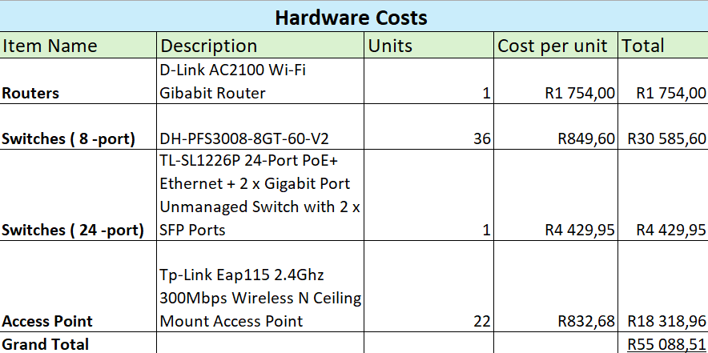

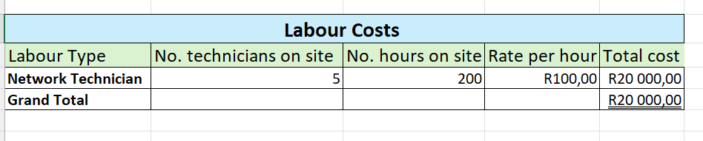

### Group Ethics Reflection on the Packet Tracer

# Challenges faced:

Overall, the network topology to be used due to the complexity and the scale of the of the building.

Designing the network for this large complex building needs careful planning to avoid future problems. Dividing the sections in a way that would minimize cable clutter and signal interference. Integrating the physical view with the logical design.

* Identifying IP addressing for each section.
* Layout of the entire section.
* Connecting different IoT devices, whether they had to be wired or wireless, identifying how to change the hardware from wireless to wired and vice versa.
* Navigation it’s not user friendly.
* Operation of the simulation in cisco packet tracer.
* Connecting end devices to an access point.

GitHub not working with cisco packet tracer proved to be the biggest issue because it limited virtual conferencing and we had to collaborate face to face.

# Bring your own device considerations:

In departments like the 13 Offices and technicians’ office, no new equipment was purchased. The equipment used i.e. smartphones and tablets and some few laptops belong to the individuals with access to these areas, they were used for demonstration purposes and did not directly affect the cost of the network in terms of expenses.

# Part of the network most likely to need maintenance:

The main router or the main switch in the machine room is most likely to require maintenance because it always has to be operational, its failure could most likely separate the whole sections from each other, the router also needs to be a powerful router and always operational since it is the only router in the entire network that helps provides internet access for the entire building. Due to budget limitations only one powerful router will be purchased however it delivers high-performance of 1Gigabit/10GB Router.

# Parts to remain if company went virtual:

The machine room housing essential equipment such as the server, router and main switch, it serves as a central hub for the network operations and maintenance. The technician’s office is also one of the areas that would remain in the event of the occurrence of network problems, they should be able to show up on site to fix the problem. Reception Area may serve multiple purposes such as monitoring the areas that remain including itself and other building components and the receptionist can always contact the technician in case a problem arises on site as they can provide them access to the building apart from technician’s office being limited to the technicians only.

Lastly the group/board meeting can serve as a venue for in-person meetings to discuss very critical issues that cannot be properly addressed through telecommunications or virtual conferencing.

# Group approach to managing project load:

Regular check-ins and scheduled meetings which typically involved reviewing processes done and to be done and discussing what challenges have been encountered, troubleshooting problems and getting the opportunity to set new goals or adjusting existing ones set on the previous meeting which would need to be completed for before the next meeting.

# Advantages:

Face to face:

Stronger collaboration: brain storming becomes easier with quick discussions and quick responses that can be tested to see if they don’t work, so we could move on to the next possible solution.

Efficient communication, confusion gets cleared up quicker.

Shared focus completing small tasks orderly or separate tasks then compiling once all have been completed.

Individual work:

Flexibility, covering unfamiliar concepts at your own time in your own comfort, having flexibility to look at different approaches or attempting to solve a problem throughout the duration of the day.

Skill development: encouraging independent problem-solving strategies and management skills.

Video conferencing:

Cost effective, no external resources used.

Allows easier collaboration in terms of distance.

# Disadvantages:

Scheduling problems, not everyone may have been able to attend due to constraints such as petrol for small group discussions.

Technical difficulties such as network problems, easily distracted if there are outside factors that catch your attention whilst video conferencing.

### Group Ethics Reflection on the Messaging App

**Group Ethic:**

The group has been regular in attending meetings. However, we needed to find the proper balance between school and personal life in terms of time management. Our meeting was always scheduled beforehand so that everyone could prepare in advance. We had great collaboration behaviour because we divided the team into two for specific aspects of the project, but we still supported each other no matter which team we were on. Meetings have been more interactive, and productive, but creating the app has proven to be difficult due to the difficulties we experienced. We scheduled meetings that involved reviewing progress on the app.

**Communication Channels:**

If we didn’t meet, we communicated through a messaging app that everyone uses or held a virtual meeting with Microsoft Teams. Any major changes were discussed here and important documents for deadlines met were shared here.

**Messaging App Reflection:**

**Challenges Faced:**

We initially planned to use HTML and JavaScript, but we decided to use Python and JavaScript. We chose Python for its simplicity of learning, readability, and flexibility in backend programming. Python is also effective in data processing and authentication. We started with JavaScript for our frontend since it allowed us to develop a user-friendly, interactive, and dynamic interface. We also added internal libraries like FastAPI and BaseModel to our backend. We chose to start by building the messaging application and then work around it while creating the server. We discovered that FastAPIs can assist with the development of a backend server and grant users access to the project. Socket and NPM components helped us to create the front-end server which we connected to the backend.

**Choosing programming language:**

Choosing a strategy to use in developing the app, given us different programming language options, made it tough to choose an effective and efficient language that everyone is comfortable with. Making the app standalone have been the most difficult task we faced, forcing us to rethink our entire strategy to fulfill the project requirements. Getting the server connected was also difficult because we couldn't send messages between two distinct devices. We also ran into a problem where the server’s IP address was different on each device and therefore the two of them communicating wasn’t possible. The first challenge we dealt with was an extension of Node.JS using a framework called Electron.js, which is used through the command prompt to convert the app from a browser to a standalone.

**Overcoming Challenges:**

We faced several challenges, including the app's standalone nature and the sending and receiving of messages across multiple machines. The first challenge was an extension of Node.JS using a framework called Electron.js, which is used through the command line to turn the app from a browser to a standalone. The second problem was solved by connecting both computers to the same server, allowing them to access the same users and interact across devices. This was achieved by using the same private key and project identifier.

**Learning and Growth:**

Creating the text messaging app helped us improve our problem-solving skills and understanding of Python and JavaScript. We learned not only technical abilities, but also communication and project management skills, which will be useful for future projects. We now have a better grasp of the frontend and backend, as well as how to connect the server and the client while exchanging messages.

**The following is a picture of the login form:**

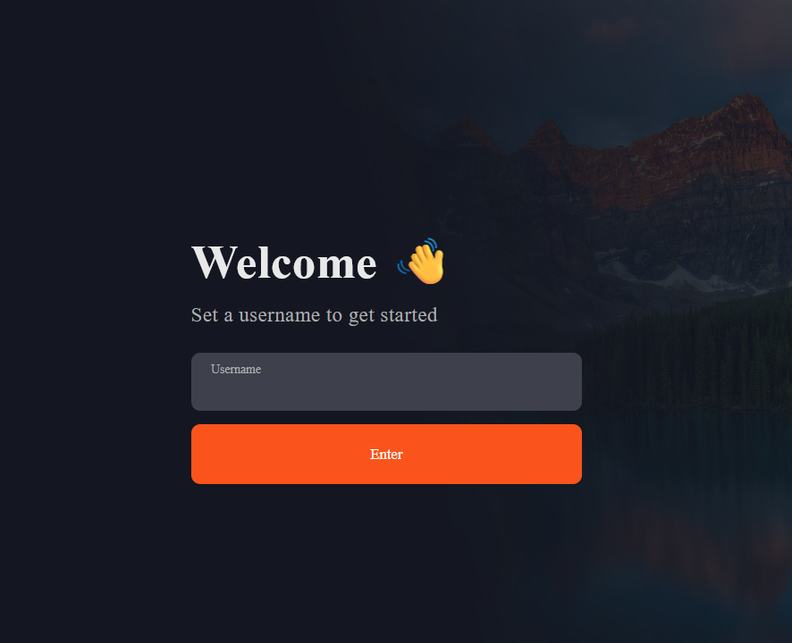

**The following is a picture of a private chat:**

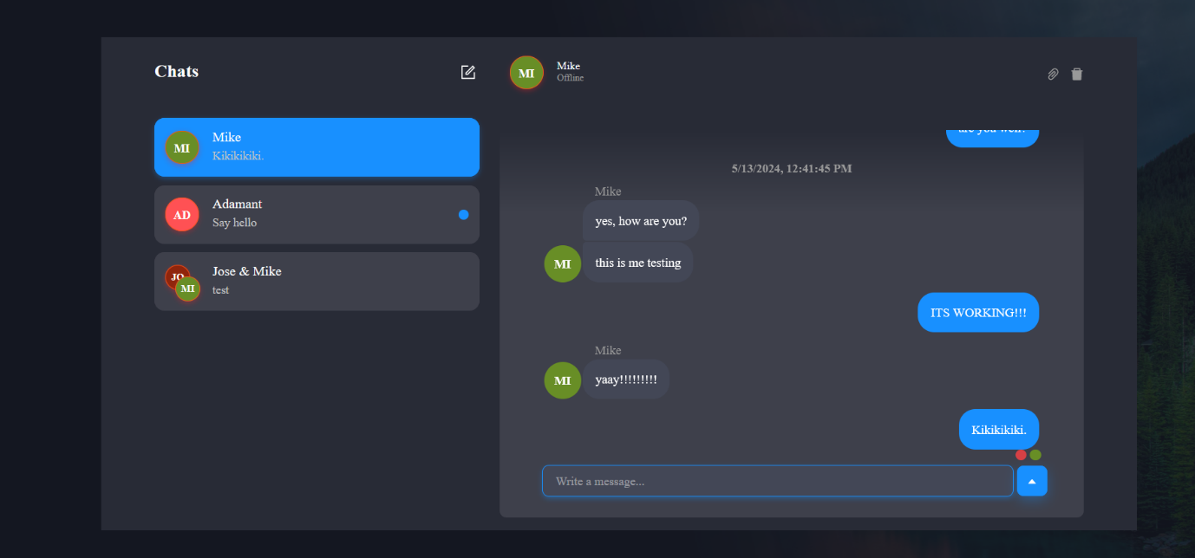

**The following is a picture of a group chat:**

**Conclusion**

Despite the challenges, our app has a user-friendly interface in which you can choose whether to send a private or group chat by clicking the search box and specifying which persons you want to send a message to. Upon running the app, users connect to the server by entering their username, allowing for seamless message exchange.

### Group Ethics Reflection on the Overall Project

**1.GROUP ETHIC**

The team has been consistent and organized in group meetings, which shows that we are well driven and motivated. A strong teamwork ethic is prevalent so far and everyone shows commitment towards the project. Producing high quality work and meeting deadlines has been the mandate. We provide constructive feedback and respect everyone’s ideas. However, we need to better manage our time and balance our academic work, so it does not become a reason for us to delay deadlines. Also, our meetings need to be more interactive so we can become more productive.

**2.Communication channels**

We only use a messaging app to communicate with each other. This is more effective as the app is used by everyone daily and we can avoid people missing updates and information on the project. This is the fastest and most efficient way to keep everyone updated on the project and important deadlines.

**3.Methods of Collaboration**

We've been using GitHub to monitor projects and deadlines and have had two in person meetings per week. This is a good approach to update everyone on the status of the project. To guarantee efficiency, the brainstorming meetings should be more organized and participatory. We should think about implementing brainstorming tools and approaches in the future to improve teamwork, as well as introducing ice breakers at the beginning of each meeting to encourage more comfort and freedom among participants. Though there's always space for development, our group functions well together overall. I think we can improve our cooperation and accomplish even more success with our project if we take care of these problems.

### Issues encountered on the Project.

Steep Learning Curve: Tools like Cisco Packet Tracer have a steep learning curve, especially for those new to networking concepts. Understanding how to effectively simulate networks with multiple devices and configurations can be challenging.

Software Limitations: Packet Tracer might not support all real-world networking devices or scenarios, which can limit the simulation's accuracy or the ability to model specific configurations.

Debugging Network Issues: Identifying and resolving issues within simulated networks can be complex, especially when dealing with advanced networking concepts like subnets, VLANs, or routing protocols.  
  
Compatibility Issues: There might be compatibility issues between the tools used for network simulation and the development environment for the messaging app. For instance, the output from Packet Tracer might not directly translate to practical insights useful for the network behavior of the messaging app.

Version Control Problems: When working in teams, maintaining consistent software versions across different development environments can lead to compatibility issues, making collaboration difficult.  
  
Programming Complexity: Building a messaging app involves understanding networking, asynchronous communication, and possibly encryption. The complexity increases if the team is not proficient in these areas.

Integration Issues: Integrating the messaging application with existing systems or ensuring it works across different platforms and networks can be difficult without a solid understanding of network programming and application design.

### Continuous Reporting part 1- Attendance list,

### meeting notes and members tasks and responsibilities.

**Meeting 1:  
Date: 08/03/2024**

**Time:** 1pm to 2pm   
**Attendance List:**

1. Nakooda, Tasmiyah (37226509)
2. Liphoko, Mohau(42524547)
3. Mabula, Palesa(37124315)
4. Mathebula, Michael(38925958)
5. Mogotlane, Nick(43230350)
6. Moremi, Olebogeng(40123316)
7. Patel, Riya(41914228)
8. Sparks, Jameela(41354850)

**Absent members:**

* 1. Makhubela,Boiphelo(41368452)
  2. DeGouveia, Marco(40899624)

**Meeting Session and Notes**

=Introduction of members

=Discussion of how everything needs to be done, deadlines

=13th onwards, everyone needs to view the the links and come with their reports to the next meeting where we will doing the final report with everyones views   
**Members Task and Responsibilities:**

The following to be done by the next meeting:

=software reflection

=GitHub

=watching the videos

=software to be downloaded   
**Tasks Completed by Whom:**All 10 members complete the reflection, courses, and software to be downloaded.

**Meeting 2:  
Date: 15/03/2024**

**Time:** 1pm to 2pm   
**Attendance List:**

1. Nakooda, Tasmiyah (37226509)
2. Liphoko, Mohau(42524547)
3. Mathebula, Michael(38925958)
4. Mogotlane, Nick(43230350)
5. Moremi, Olebogeng(40123316)
6. Patel, Riya(41914228)
7. Sparks, Jameela(41354850)
8. Makhubela,Boiphelo(41368452)
9. DeGouveia, Marco(40899624)

**Absent members:**

1. Mabula, Palesa(37124315)

**Meeting Session and Notes**

=Extension of the reflection documentation

=Videos to be watched

=Software to be downloaded

=Github project created

=Project planning: to be initiated

=Watching YouTube video of the packet tracer

**Members Task and Responsibilities:**

The following to be done by the next meeting:

=Watching of courses: 22/03

= Reflection and software to be downloaded: 29/03

= Tasks for task 3 : overview and description of network topology

= 4th and 5th april: thurs and fri meeting at 11am and 1pm

=Budget and issues : 11th of april

=Eval and lessions learnt from project : 18th and 19th of april

=Text messaging app : 26 and 3rd April

=Finalise whole project: 10th to 16th of may

**Tasks Completed by Whom:**All 10 members complete the reflection, courses, and software to be downloaded.

**Meeting 3**

**Date: 15/04/2024**

**Time:** 1pm to 2pm   
**Attendance List:**

1. Nakooda, Tasmiyah (37226509)
2. Liphoko, Mohau(42524547)
3. Mabula, Palesa(37124315)
4. Mathebula, Michael(38925958)
5. Mogotlane, Nick(43230350)
6. Moremi, Olebogeng(40123316)
7. Patel, Riya(41914228)
8. Sparks, Jameela(41354850)
9. Makhubela,Boiphelo(41368452)
10. DeGouveia, Marco(40899624)

**Absent members:**

None

**Meeting Session and Notes**

=Speaking about documentation that needs to be done

=Going over rubric

=Total 180

=40 marks is documentation

=20 marks is presentation

=Going through questions that was asked by prev students in the meeting  
**Members Task and Responsibilities:**

Assigning everyone different tasks

Boipelo – Group Ethic

Tasmiyah – Time Table

Riya – Continuous reporting

Michael & Mohau – Reflection on the packet tracer

Nick & Jameela – Reflection on the messaging app

Marco & Olebogeng – Description of the network topology

Mohau – Overview of the problem

Boipelo – Explaining the network topology using diagrams

Riya, Tasmiyah & Palesa – Budget

Michael – Discuess issues encountered

The following to be done by the next meeting:

= Familiarize yourself with the packet tracer

=Sketch your own design for it

= Overview, Group Ethic reflection, reporting (Marco, Boipelo, Riya)

**Tasks Completed by Whom:**All 10 members downloaded the software, and watched videos for the packet tracer

**Meeting 4:  
Date: 12/04/2024**

**Time:** 1pm to 2pm via zoom  
**Attendance List:**

1. Nakooda, Tasmiyah (37226509)
2. Liphoko, Mohau(42524547)
3. Mabula, Palesa(37124315)
4. Mathebula, Michael(38925958)
5. Mogotlane, Nick(43230350)
6. Moremi, Olebogeng(40123316)
7. Patel, Riya(41914228)
8. Sparks, Jameela(41354850)
9. Makhubela,Boiphelo(41368452)
10. DeGouveia, Marco(40899624)

**Absent members:**

None

**Meeting Session and Notes**

=Problem overview discussion

=Talking about the packet tracer

= Group discussion which entails, how many devices needs to be placed in each room, which devices will be used

**Members Task and Responsibilities:**

The following to be done by the next meeting:

Riya, Palesa & Tasmiyah – Discussion of next meeting for the budget

**Tasks Completed by Whom:**Marco – Overview of the problem sent

Riya – Continuous reporting sent

**Meeting 5**

**Date: 17/04/2024**

**Time:** 1pm to 2pm   
**Attendance List:**

1. Nakooda, Tasmiyah (37226509)
2. Mabula, Palesa(37124315)
3. Patel, Riya(41914228)

**Absent members:**

None (Meeting was just for Riya, Palesa, Tasmiyah)

**Meeting Session and Notes**

= Discussion about prices for the devices used

= Wi-Fi access points, Switches , Routers

= Doing research about the different types of devices and which price will be chosen

= Doing a variety: ranging from expensive to cheap  
**Members Task and Responsibilities:**

Riya – Research on all the first devices

Tasmiyah- Research on all the second devices

Palesa – Research on all the third devices

**Tasks Completed by Whom:**N/A

**Meeting 6**

**Date: 18/04/2024**

**Time:** 1pm to 2pm   
**Attendance List:**

1. Nakooda, Tasmiyah (37226509)
2. Liphoko, Mohau(42524547)
3. Mabula, Palesa(37124315)
4. Mathebula, Michael(38925958)
5. Mogotlane, Nick(43230350)
6. Patel, Riya(41914228)
7. Makhubela,Boiphelo(41368452)
8. DeGouveia, Marco(40899624)

**Absent members:**

1. Moremi, Olebogeng(40123316)
2. Sparks, Jameela(41354850)

**Meeting Session and Notes**

=Discussion about packet tracer

=Discussion about messaging app

**Members Task and Responsibilities:**

=While packet tracer people are working on packet tracer

=Messaging app people are doing research as to what approach can be used

**Tasks Completed by Whom:**Packet tracer group: Sketches brought to the meeting

Riya – Continuous reporting

**Meeting 7**

**Date: 19/04/2024**

**Time:** 1pm to 3pm   
**Attendance List:**

1. Nakooda, Tasmiyah (37226509)
2. Liphoko, Mohau(42524547)
3. Mabula, Palesa(37124315)
4. Mathebula, Michael(38925958)
5. Mogotlane, Nick(43230350)
6. Moremi, Olebogeng(40123316)
7. Patel, Riya(41914228)
8. Sparks, Jameela(41354850)
9. Makhubela,Boiphelo(41368452)
10. DeGouveia, Marco(40899624)

**Absent members:**

None

**Meeting Session and Notes**

= Continuation of packet tracer

= Watching of videos for the messaging app

= Trying an approach to work with the messaging app

= Downloading of JavaScript and software’s

**Members Task and Responsibilities:**

Messaging app group- working on messaging app

Packet tracer group – working on packet tracer

**Tasks Completed by Whom:**N/A

**Meeting 8**

**Date: 30/04/2024**

**Time:** 11am to 12:30pm   
**Attendance List:**

Messaging group app

**Meeting Session and Notes**

= Working with the clone idea for the messaging app

= Trying to figure out a way to send and receive messages

**Tasks Completed by Whom:**Messaging group app – videos watched

**Meeting 9**

**Date: 04/05/2024**

**Time:** 2pm to 6pm   
**Attendance List:**

Packet Tracer group

**Meeting Session and Notes**

=Configuration of the offices

= Testing the packet tracer and network

**Members Task and Responsibilities:**

Tasmiyah- Updating GitHub, screenshots

Riya – Continuous reporting

Messaging app group- Reflection needs to be done

Michael & Boipelo – Group reflection on the packet tracer

Palesa- Network Topology

Boipelo- How many devices needs to be used

Marco- Configuration and how the overall network is structured

Tasmiyah- Discuss issues encountered

Riya, Tamiyah & Palesa – start working on the budget

**Tasks Completed by Whom:**Tasmiyah & Marco – Packet tracer file sent

**Meeting 10**

**Date: 05/05/2024**

**Time:** 1pm to 3pm   
**Attendance List:**

Packet Tracer group

**Meeting Session and Notes**

= Packet tracer

= Marco figuring out his part

= Tasmiyah will be fixing the wireless connections

= Palesa and Mohau connection of switches to main switch  
**Tasks Completed by Whom:**Packet tracer group- files sent

**Meeting 11**

**Date: 06/05/2024**

**Time:** 2pm to 6pm   
**Attendance List:**

1. Nakooda, Tasmiyah (37226509)
2. Liphoko, Mohau(42524547)
3. Mathebula, Michael(38925958)
4. Mogotlane, Nick(43230350)
5. Moremi, Olebogeng(40123316)
6. Patel, Riya(41914228)

**Absent members:**

1. Mabula, Palesa(37124315)
2. Makhubela,Boiphelo(41368452)
3. DeGouveia, Marco(40899624)
4. Sparks, Jameela(41354850)

**Meeting Session and Notes**

=Messaging app group

= Initially started with a clone idea, but due to some technical issues, we shifted towards another approach

**Tasks Completed by Whom:**Messaging app group = links to YouTube videos sent

**Meeting 12**

**Date: 07/05/2024**

**Time:** 15:00pm to 19:30pm   
**Attendance List:**

Messaging app group

**Meeting Session and Notes**

= Making sure the server is running so that the sending and receiving of messages can be done

= Watching of videos

= Making sure that the app doesn’t open through a web browser

**Tasks Completed by Whom:**Messaging app group worked divided and completed

**Meeting 13**

**Date: 09/05/2024**

**Time:** 16:30pm to 18:30pm   
**Attendance List:**

1. Nakooda, Tasmiyah (37226509)
2. Liphoko, Mohau(42524547)
3. Mathebula, Michael(38925958)
4. Mogotlane, Nick(43230350)
5. Moremi, Olebogeng(40123316)
6. Patel, Riya(41914228)
7. Sparks, Jameela(41354850)
8. Makhubela,Boiphelo(41368452)
9. DeGouveia, Marco(40899624)

**Absent members:**

1. Mabula, Palesa(37124315)

**Meeting Session and Notes**

=Trying to fix the messaging app and making sure the servers are connected and running

=Packet tracer group fixing the issues that they encountered

The following to be done by the next meeting:

=Test the app and check that it meets all the requirements

= Everyone must have their individual documentation parts complete- need to combine the remaining parts

= Discuss how we taking the video

= Prepare for our presentation and assign roles

= Go through the entire rubric to make sure everything is covered

**Tasks Completed by Whom:**Messaging app group and packet tracer group worked divided and completed

**Meeting 14**

**Date: 13/05/2024**

**Time:** 14:00pm to 18:30pm   
**Attendance List:**

1. Nakooda, Tasmiyah (37226509)
2. Liphoko, Mohau(42524547)
3. Mathebula, Michael(38925958)
4. Mogotlane, Nick(43230350)
5. Moremi, Olebogeng(40123316)
6. Patel, Riya(41914228)
7. Sparks, Jameela(41354850)
8. Makhubela,Boiphelo(41368452)
9. DeGouveia, Marco(40899624)
10. Mabula, Palesa(37124315)

**Absent members:**

None

**Meeting Session and Notes**

=Trying to fix the messaging app and making sure the servers are connected and running

=Packet tracer group fixing the issues that they encountered

= Trying to get the messaging app to not open via a web browser

= Fixing any technical issues with messaging app

= Connecting the packet tracer and making sure everything works

**Tasks Completed by Whom:**Messaging app group and packet tracer group worked divided and completed.

**Meeting 15**

**Date: 14/05/2024**

**Time:** 13:00pm to 15:00pm   
**Attendance List:**

1. Nakooda, Tasmiyah (37226509)
2. Mathebula, Michael(38925958)
3. Mogotlane, Nick(43230350)
4. Moremi, Olebogeng(40123316)
5. Patel, Riya(41914228)
6. Sparks, Jameela(41354850)
7. Makhubela,Boiphelo(41368452)
8. DeGouveia, Marco(40899624)
9. Mabula, Palesa(37124315)
10. Liphoko, Mohau(42524547)

**Absent members:**

None

**Meeting Session and Notes**

=Trying to fix the messaging app and making sure the servers are connected and running

=Packet tracer group fixing the issues that they encountered

= Finalizing the budget for the project  
**Tasks Completed by Whom:**Messaging app group and packet tracer group worked divided and completed

**Meeting 16**

**Date: 15/05/2024**

**Time:** 16:00pm to 20:00pm   
**Attendance List:**

1. Nakooda, Tasmiyah (37226509)
2. Mathebula, Michael(38925958)
3. Mogotlane, Nick(43230350)
4. Moremi, Olebogeng(40123316)
5. Patel, Riya(41914228)
6. Sparks, Jameela(41354850)
7. DeGouveia, Marco(40899624)
8. Mabula, Palesa(37124315)
9. Liphoko, Mohau(42524547)

**Absent members:**

1. Makhubela,Boiphelo(41368452)

**Meeting Session and Notes**

= Finalizing the entire project  
**Tasks Completed by Whom:**Messaging app group and packet tracer group worked divided and completed

Finalizing of project and completing documentation.

### Screenshots on GitHub use

